**Var dep: CVdep14_MoyInd_ExistPb**

**Variables indep select**:

variables_independientes = ['0_Nome_atu', ,'A8_Indeg_ApoioLevDiqCintura', 'A11_Indeg_Con1Re2DiqPriqDiqCint','B1_VarExp_IndForcaFugon', 'B2_VarExp_IndInvestDiq','B3_VarExp_IndMelhorTecnDiqCint', BX_ClassZona']

**Parametres Modele**:

Test_size: 0.18

Random_state: 9

N_estimators: 150

**Scores testing**:

Mean Squared Error: 0.1301

R^2 Score: 0.4689 (**Sur Excel: R2 = 0.5435 ; Y = 0.345 X + 0.2583**).

**Interactions:**

| **Interacción** | **Importancia** | **Dirección** |
| --- | --- | --- |
| 0 | (B2_VarExp_IndInvestDiq, B3_VarExp_IndMelhorTe... | 0.116651 | -0.057080 |
| 1 | (A11_Indeg_Con1Re2DiqPriqDiqCint, B2_VarExp_In... | 0.113798 | -0.011109 |
| 2 | (A6_Indeg_ApoioSpeDiqCint, B2_VarExp_IndInvest... | 0.105599 | 0.020743 |
| 3 | (B2_VarExp_IndInvestDiq, BX_ClassZona) | 0.101044 | -0.029325 |
| 4 | (A8_Indeg_ApoioLevDiqCintura, B2_VarExp_IndInv... | 0.099732 | 0.000449 |
| 5 | (A11_Indeg_Con1Re2DiqPriqDiqCint, B3_VarExp_In... | 0.077833 | -0.011676 |
| 6 | (B3_VarExp_IndMelhorTecnDiqCint, BX_ClassZona) | 0.075414 | -0.010142 |
| 7 | (A8_Indeg_ApoioLevDiqCintura, A11_Indeg_Con1Re... | 0.074798 | -0.000520 |
| 8 | (A11_Indeg_Con1Re2DiqPriqDiqCint, BX_ClassZona) | 0.069551 | -0.011238 |
| 9 | (A8_Indeg_ApoioLevDiqCintura, BX_ClassZona) | 0.068243 | 0.001607 |

**Scores ALL modelo**:

Mean Squared Error (MSE): 0.0554

Root Mean Squared Error (RMSE): 0.2354

Mean Absolute Error (MAE): 0.2048

R^2 Score: 0.7692

Pearson Correlation: 0.9302

**Results**:

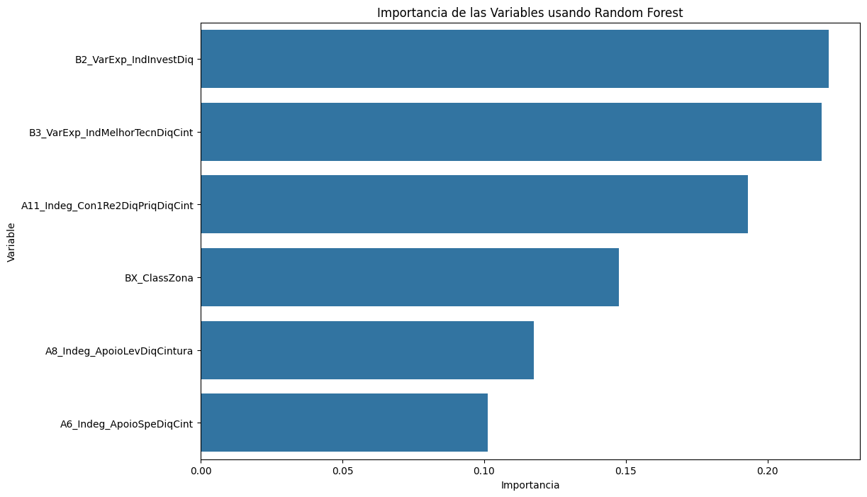

**Correlations**:

